Search Committee Member
Reviewing Applicants On-Line Recruitment & Applicant Tracking System http://employment.stlawu.edu/hr
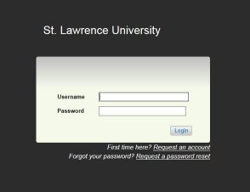
Log in with your username (first initial and last name) and same for initial password

You will be prompted to change your password after your first login attempt.
Note: If you have multiple views in the system (Hiring Manager, Search Committee Member, Search Chair) make sure you are logged in as Search Committee Member.
- On the menu bar at the top of the page select the postings tab and then faculty, staff or adjunct/temp, based on the type of search being conducted.
- Located on the same line as the posting number, go to the blue “Actions” drop-down menu and select “View Applicants.”
- On the same line as the applicant's name, go to the blue “Actions” drop-down menu and select “View Application.”

- Once you have reviewed that application, select “Applicant Review” from the menu at the top of the page to return to the full list of applicants.

